

APP 133 Master Test Plan Work Product

Call Center Application Desktop
Author: IBM Global Business Services

January 26, 2007
Document History
Document Location
This is a snapshot of an on-line document. Paper copies are valid only on the day they are printed. Refer to the author if you are in any doubt about the currency of this document.
The source of the document can be found in Rational Portfolio Manager.
Revision History
Date of this revision: 10/04/2012 | Saved by: Jeff Berk

Revision Number | Revision Date | Author | Summary of Changes | Changes marked
0.01 | 01/09/07 | Kurt J Solarte | Initial Draft | N
0.02 | 01/19/07 | Kurt J Solarte | Initial Complete Draft | N
0.03 | 01/23/07 | Kurt J Solarte | Changes based on feedback from Team, editing based on project standards | Y
1.0 | 01/24/07 | Kurt J Solarte | Final Revisions based on feedback from team, and addition approvers/Distribution from PMO | N
1.1 | 01/26/07 | Chris Garrett | Incorporated Eugene Blomberg comments. | N
Approvals
This document requires following approvals. Signed approval forms are filed in the Quality section of the PCB.
Name | email | Title / Role
Julie Aldrich | julie.aldrich@cigna.com | CCA Business Lead
Distribution
This document has been distributed to
Name | email | Title / Role
Leigh Defreitas | leigh.drennan@cigna.com | CCA IT PM
Kerry Kelley | kerry.kelley@cigna.com | Business Analyst
Scott Baumer | scott.baumer@cigna.com | System Analyst
Jerry McDonald | gerald.mcdonald@cigna.com | Program Quality Assurance Manager
Debra Goldberg | debra.goldberg@cigna.com | CCA Testing Director

Table of Contents
1. Introduction 8
1.1 Description 8
1.2 Purpose 8
1.3 Audience 9
2. Executive Summary 10
2.1 Overview 10
2.2 System Environment 10
2.3 Test Process Model 11
2.4 Table of Required Testing 12
3. Test Scope 13
3.1 Testing Phase Overview 13
3.2 Test Phases - Guidelines for Implementation 14
3.2.1 Recommended Testing from Testing Strategy 14
3.3 Test Types – Guidelines for Implementation 16
3.3.1 Unit Test 16
3.3.2 Function Test 17
3.3.3 System Test - Business Process Testing 18
3.3.4 Usability Testing 19
3.3.5 Performance Testing 20
3.3.6 System Integration Testing 21
3.3.7 User Acceptance Testing 22
3.3.8 Pre-Prod / Release Testing 23
4. CCA Test Focus – Content/Methods/Techniques 24
4.1 Content to Be Tested - Items and Features 24
4.2 CCA Content Not To Be Tested - Items and Features out of Scope 25
4.3 Test Case Design/Preparation to Achieve Requirements Coverage 25
4.3.1 Test Data to Achieve Coverage 27
4.4 Requirements Traceability 29
5. Processes and Procedures 30
5.1 Configuration Management and Build 30
5.2 Test Status Reporting 31
5.3 Defect Management Process 32
5.3.1 CCA Application Defects 32
5.3.2 Infrastructure Defects 32
5.3.3 Test Defect Reporting 32
5.4 Test Completion Report 33
5.5 Test Requirements 33
5.6 Test Assumptions 34
5.7 Test Constraints 34
5.8 Risks 34
5.9 Impact of the Iterative Approach 35
5.10 External Dependencies 36
6. Key Input Documents 37
7. Resources 38
7.1 Roles and Resources 38
7.2 Test Environments 39
7.3 Tools 41
7.4 Defect Management 41
8. Timeline 43
8.1 Test Milestones 43
8.2 Conceptual Schedule 43
9. Deliverables 44
9.1 Test Deliverables 44
9.1.1 Book of Record 44
9.2 Metrics 44
10. Appendix 46
10.1 Appendix A: Use Case Survey 46
10.2 Appendix B: Test Entrance Criteria 46
10.3 Appendix C: Test Exit Criteria 49
10.4 Appendix D: Test Plan Glossary 51
10.5 Appendix E: Screen Cap of RAD Test Harness 53

Table of Figures

Figure 1: IBM Test Process Model Summary 11
Figure 2: Summary of Required Testing 12
Figure 3: Lifecycle Testing Model 13
Figure 4: Test Phase Matrix 14
Figure 5: Unit Test Guideline Grid 16
Figure 6: Function Test Guideline Grid 17
Figure 7: Business Process Test Guideline Grid 18
Figure 8: Usability Test Guideline Grid 19
Figure 9: Performance Test Guideline Grid 20
Figure 10: System Integration Test Guideline Grid 21
Figure 11: User Acceptance Test Guideline Grid 22
Figure 12: Pre-Prod Test Guideline Grid 23
Figure 13: Content to be Tested 24
Figure 14: Features and Functions not to be Tested 25
Figure 15: Test Case Development Model 26
Figure 16: Test Case to Requirements Mapping Model 28
Figure 17: Requirements Mapping 29
Figure 18: Defect Lifecycle 31
Figure 19 Defect Status 33
Figure 20: Test Dependencies 36
Figure 21: Key Input Documents – Deliverables 37
Figure 21: Roles and Resources 38
Figure 22: Environments 39
Figure 23: Testing Tools 41
Figure 24: Defect Severity Codes 42
Figure 25: Conceptual Schedule 43
Figure 26: Matrix of Test Deliverables 44
Figure 27: Metrics 44
Figure 28: Test Entrance Criteria 46
Figure 29: Test Exit Criteria 50
Figure 30: Test Plan Glossary 51
Figure 31: Rational Test Harness Creation 53

Introduction

Description
The Master Test Plan is a document of understanding on testing between the various stakeholders of the project. It documents the "what" (scope and objectives), the "why" (purpose), the "when" (key milestones), and the "who" (organizational roles and responsibilities) for all levels of dynamic testing. Full lifecycle testing is an iterative process and the Master Test Plan is central to ensuring coverage during Full lifecycle testing. The development of the master test plan is started early in the development lifecycle, and is refined, as more information becomes available. It ties together all the detailed test plans and points to them. Each testing level represents a known level of physical integration and quality of the system solution under development.
The CCA Master Test Plan describes:
- Overall Entrance and Exit Criteria
- Requirements Coverage
- Development of manual test cases within Rational TestManager
- Development of automated test scripts using JUnit and Rational Robot
- Uses of development environments for Test
- Uses of the Test environments for Testing
- Development of Test Execution plans and procedures
- Approach to verifying and reporting test results

Purpose
The purpose of the Master Test Plan work product is to:
- Address testing from a high-level system viewpoint.
- Provide a big picture view, or a view of the forest, whereas the detailed test plans provide views of the trees in the forest.
- Provide an early definition of the test environment requirements.
- Ensure that the test plans are built systematically and completely and there is no more and no less overlap between detailed test plans than is necessary.
The CCA master test plan provides planning information, ahead of time, to alert the organizations to get ready for testing by allocating the right set of resources at the right time. By providing high level requirements for hardware, software, and people resources as early in the lifecycle as possible, there is more likelihood that the resources will be planned, prepared, acquired, and trained in a timely manner.

Audience
The following have been identified as the audience for this document.
- Business Stakeholders
- Business Lead
- Test Team
- Business Analysts / SMEs
- Solution Architect
- Data Architect
- Application Designers
- Application Developers

Executive Summary

Overview
The CRM Capabilities Initiative evolves from CIGNA's Strategy to achieve the following business imperatives:
- Integrated Execution - Seamless marketing, Sales and Service processes across the Enterprise
- Outreach and Dialogue - Pro-active and intelligent communication to build advocacy and promote CIGNA offerings
- Stakeholder Insight - Management of stakeholder information as a strategic asset.
Call Center Application (CCA) is one of several delivery efforts within CIGNA’s CRM Capabilities Program. The project will deliver a desktop application for CIGNA Customer Service Agents (CSAs) to be deployed across multiple lines of business (Medical, Pharmacy, Dental, Group Insurance, Intracorp, and Behavioral Health) to track constituent interactions, manage follow-up on constituent issues, and access back-end source applications and data needed to resolve issues and respond to inquiries.
CCA will replace CIGNA’s existing Siebel iCare CRM solution, currently deployed to the Medical and Pharmacy lines of business, and its existing CSS CRM application, used in the Dental and Pharmacy lines of business.

System Environment
The CCA Desktop solution is a WebSphere Portal/Chordiant CSA desktop application to support CRM requirements across CIGNA’s lines of business. The solution will include:
- A role-based portal that provides a unified CSA desktop;
- A new Enterprise Services Bus (ESB) that will be integrated with CIGNA’s planned Enterprise Services Bus to support the deployment of SOA services and enable access to required data across multiple legacy applications;
- Contextual knowledge integrated with CCA;
- Automated dialing capability integrated within CCA.
The CCA Desktop architecture is a modular design that incorporates WebSphere Portal, Chordiant Business Services, Chordiant Databases, CTI Chordiant Framework, WebSphere App Server, Tivoli Access Manager and DB/2 into a powerful solution when coupled with custom coding and SOA principles.
The Master Test Plan is intended to be a set of quality guidelines to ensure complete and comprehensive testing of the applications under test.
Testing guidance is provided for application testing to ensure the following points are applied consistently within the Development Lifecycle namely:

- Applications Integrating with CCA – The CCA Desktop Application is sufficiently complex having many integration points namely WebSphere Portal, Chordiant Business Services, Chordiant Databases, CTI Chordiant Framework, WebSphere App Server, Tivoli Access Manager and DB/2 into a powerful solution when coupled with custom coding and SOA principles. Testing between these integration points must be aligned with each team providing the same quality levels at Unit, Function, System, SIT and UAT testing intervals.
- Development Organizations providing Code/Objects To Be Imbedded in CCA – To maintain consistency in quality and to preserve testing timeline, Services Objects that are provided to CCA must conform to expected Quality Levels. There will be Services Objects provided by the CIGNA team to be used by CCA thus expected quality levels must be established.
- Consistency in Testing Between Development Teams – Development strategies mandate that different teams provide different code segments for example Chordiant Team, Portal Team and ESB Teams. It is expected that each team will follow a common blue print for Unit and function Testing. This will ensure that at System Test Entry, all code has undergone similar rigor of Unit and Function Testing. Follow on sections will address Unit and Function Test expectations.

The Test Process Model in the follow-on section illustrates the various development phases, testing artifacts and testing phases making up the Development Lifecycle.

Test Process Model
The figure below illustrates the Life Cycle Testing Model to be applied to CCA Desk-top Testing
Figure 1: IBM Test Process Model Summary
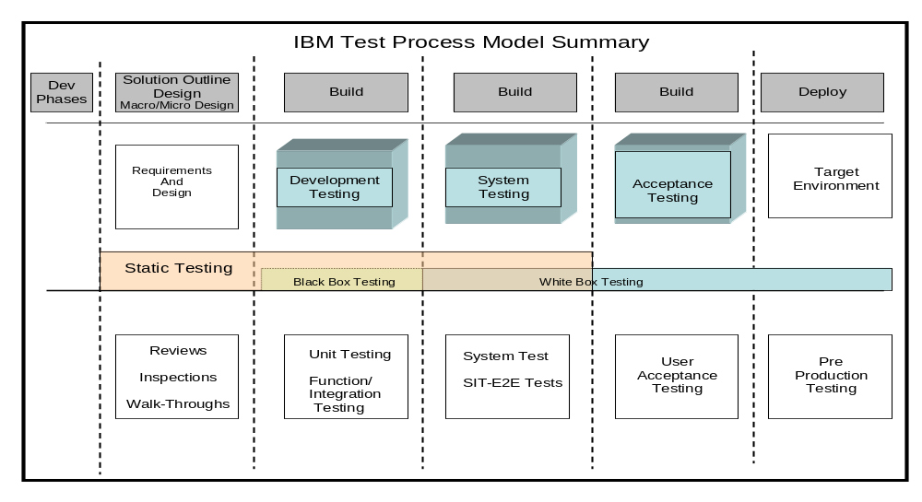

Table of Required Testing
Figure 2: Summary of Required Testing
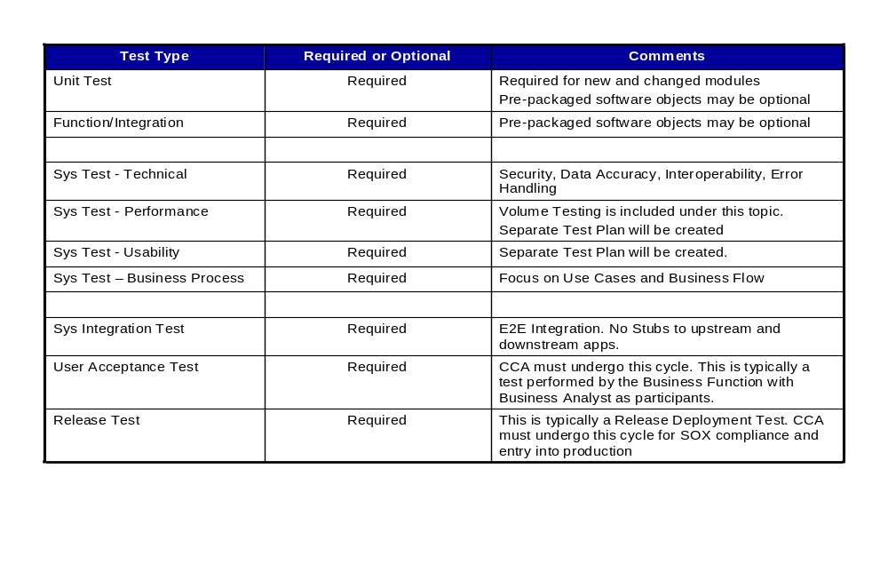

Test Scope

Testing Phase Overview

The chart below provides a summary view of the test types to be applied to CCA Desk Top Testing.
Figure 3: Lifecycle Testing Model
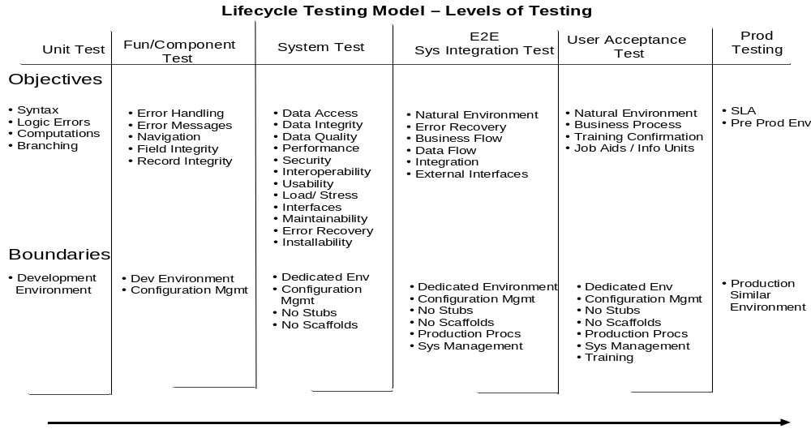

Test Phases - Guidelines for Implementation
The following sections will address the specific guidelines established for each testing level. These guidelines should be followed by the owner of that testing level. Deviations to these guidelines should surface during Micro Design to allow sufficient assessments of risk and alternatives.

Recommended Testing from Testing Strategy
Figure 4: Test Phase Matrix
Dev Phase | Testing Required | Test Description | Applicability
Build | Unit Testing | Unit Testing ensures that changed modules execute accurately; and error logic, calculations and error messaging occurs correctly | Perform on each module containing new and changed source code
Build | Functional/  Component Testing | Functional/Component Testing ensures that individual components meet feature specifications. All component/functional testing is based on written test cases, and the number of testing cycles will be driven by defect discoveries. Additional cycles may be needed based on the complexity of the component. | Perform on each component created or changed
Build | System Testing:  Business Process | System Testing ensures accurate integration of modules and the outcomes achieves expected results namely in areas of error handling, data handling, data accuracy, GUI content and GUI layout. Business Scenario Test cases will execute to confirm security, data management, error messaging and process flow. | Perform on CCA Desk Top
Build | System Testing:  Performance Tests | Performance Testing provides evidence of acceptable system resource utilization and response times under varying workload conditions; mostly high workload conditions. Additionally, specific workload requirements (Volumes) are declared in the non-functional requirements document. Testing will occur to ensure that these requirements are satisfied. | Perform on CCA Desk Top
Build | System Testing:  Usability Tests | Usability Testing confirms that usability requirements and specifically guidance for navigation, UI Design and Key-stroke requirements have been satisfied. | Perform on CCA Desk Top
Build | System Integration  Testing | Integration Testing ensures that interfaces, feeds, exports and data exchanges occur correctly with upstream and downstream applications. Additionally, SIT ensure that end-to-end processing occurs correctly between Internal and external interfacing applications | Perform on CCA Desk Top
Build | User Acceptance  Testing | User Acceptance Testing permits Business Users and SMEs to access the application prior to production to validate capability and requirements. | Perform on CCA Desk Top
Deployment | Pre-Production  Testing | Pre-Production Testing is the final execution cycle prior to move to production. This test can also be viewed as Release Test. The Release Test allows the application to co-exist in a production similar test environment with other enterprise applications. Pre-defined execution cycles are conducted to simulate month end, quarter end or Year End Processing. | Perform on CCA Desk Top Application. This typically is a Deployment Test thus ownership must be determined if test ownership or deployment ownership.
As Required | Regression  Testing | Regression Testing – Not to be confused with bug fix testing. Regression testing is the repetition of a static set of test cases to ensure that software changes have not created any unexpected results in an application. All types of testing can include regression testing for verification. These tests have broad coverage and tend to validate that defects have not occurred due to application change | Perform when application changes occur and the need exist for broad validation that processing capability is preserved after code change or procedure change

Test Types – Guidelines for Implementation
Deviations to guidelines established in this chapter should be communicated to the QA and Testing Leader during Micro Design. Since the Master Test Plan is evolutionary and can be amended, additional Quality Management testing steps may surface to enhance Solution Quality.

Unit Test
Figure 5: Unit Test Guideline Grid
Guidance | Description | Comments
Ownership | - Code Developers will own Unit Level Testing
Standard | - All newly generated modules or modules that are changed or altered must undergo a Unit Test
Objectives | - Unit/Module level validation of Logic  - Validation of Branching/Computations  - Confirm data handling, error handing  - Address packaging errors, system generated warnings, syntax errors | Unit Testing Pre-Packaged Objects:  Testing will differ for pre-package unit testing. The developer will adjust the configurable object and integrate them into the package for string level verification. Out-of-the box objects will have undergone Unit Level Testing by the manufacturer.
Methodology  Preparation | - Developers examines and identify modules/units for necessary testing  - Developer identify logic paths and data needed for testing  - Developer manufactures test data suitable for testing logic paths
Methodology - Execution | - JAVA Code – The JUNIT Testing Framework must be used to perform unit testing.
Configuration Management/ | - During Unit Test, it is not require to formal version control and configuration. Developers can perform testing
Deliverables | - Developers will produce a JUNIT “Test Method” that can be automatically run from within the J-UNIT Test Framework. See a sample within the appendix of the messaging generated when the testing harness is produced.
Tools | - Rational Application Developer and JUnit eclipse plug-in must be used as the Tools for Unit Testing.

Function Test
Figure 6: Function Test Guideline Grid
Guidance | Description | Comments
Ownership | - Function team and Development team will co-own Function Test
Standard | - All newly generated modules or modules that are changed or altered must undergo a Function Test
Objectives | - Functional validation of Logic  - Validation of Branching/Computations  - Confirm data handling, error handing  - Address packaging errors, system generated warnings, syntax errors
Methodology  Preparation | - Test Team examines and identifies packages for necessary testing  - Developer identify logic paths and data needed for testing  - Developer manufactures test data suitable for testing logic paths
Methodology - Execution | - Rational Test Harnesses produced from inside Rational Application Developer and deployed to the Function Test Environment.
Configuration Management/ | - Developers will have unit tested the code, checked it in to Rational ClearCase, and deployed a build to the Functional Test Environment.
Deliverables | - Developers will produce a Web Service “test harness” that can be automatically produced from within Rational Application Developer
Tools | - Rational Application Developer and Rational FunctionalTester must be used as the Tools for Function Testing.

System Test - Business Process Testing
Figure 7: Business Process Test Guideline Grid
Guidance | Description | Comments
Ownership | - CCA test team will own Business Flow/Process testing
Standard | - Ensure business process flows are tested for completeness; a business process flow may include several use case scenarios.
Objectives | - Validation of Business Process Flows (High Level)  - Validate business processes occur sequentially (or as specified by requirements)  - Data Validation, this includes system & database updates | Examples: of a Business Process Flow.  - Disputing a Claim  - Creating a Work Request
Methodology  Preparation | - CCA testers examine and identify groups of test scenarios that will be used to create a business process flow.  - CCA testers verifies test data is available in each environment necessary to execute the entire business process flow
Methodology - Execution | - Business Flow/Process testing will use several tools including the Rational Testing Suite, database viewers(used to validate data) & tools used to obtain screen captures
Configuration Management/  Test Environment Considerations | - During testing, formal version control and configuration is required to maintain environment valid for testing Business Flow Process scenarios.  - The SIT environment is ideal environment for testing
Deliverables | - Business Flow/Process Test scenarios (comprised of multiple test cases)  - Provide screen captures for validation of results, when applicable.
Tools | - Rational Testing Suite, SnagIt, DB2 viewer

Usability Testing
Figure 8: Usability Test Guideline Grid
Guidance | Description | Comments
Ownership | - Test Leads and Development Leads will own Usability Level Testing
Standard | - All completed builds will enter Usability Testing after exiting SIT
Objectives | - To gain final sign off by the CIGNA that the Usability Requirements have been met.
Methodology  Preparation | - Development Leads, Test Lead, and BA Lead will determine Scenario Test Scripts that the Client Usability Testers will be instructed to run.
Methodology - Execution | - CIGNA SMEs will run through the selected Scenario Test Scripts under the guidance of the Usability Test Team.
Configuration Management/ | - The builds will be managed in Rational ClearCase  - The whole iteration build will have passed SIT test before entering into Usability Test
Deliverables | - Test Team will deliver Scenario Test Scripts to the CIGNA SMEs.  - The CIGNA SMEs will deliver sign-off on the iteration build.
Tools | - Rational TestManager, Microsoft Excel

Performance Testing
Figure 9: Performance Test Guideline Grid
Guidance | Description | Comments
Ownership | - CCA Performance Test Team will own Performance Level Testing
Standard | - A complete and System Integration Tested build will be ready for Performance Test
Objectives | - To test the non-functional requirements around performance and volume.  - To test that the system meets all SLAs in regards to System Performance
Methodology  Preparation | - Code build passes all SIT  - Test Team identifies which of the System Test scripts can be automated and added to performance test scripts.  - Test Team and Infrastructure Team work together to ensure environment is same as production environment
Methodology - Execution | - Test are executed at off business times to ensure controlled environment in regards to use and volumes
Configuration Management/  Test Environment Considerations | - The build will be checked in to Rational ClearCase and have passed all SIT test cases as laid out in Rational TestManager.  - Environment must be same as production environment for Performance Metrics to be valid
Deliverables | - The Test Team will deliver the Rational PerformanceTester out-of-the-box Performance Metric graphs and reports.
Tools | - Rational Application Developer, Rational FunctionalTester, and Rational PerformanceTester will be used for Performance Test Phase.

System Integration Testing
Figure 10: System Integration Test Guideline Grid
Guidance | Description | Comments
Ownership | - CCA test team will own System Integration level testing
Standard | - All new and modified integration components that impact CCA application must undergo testing
Objectives | - Validation of System Integration from end-to-end based on Business Processes  - To ensure the completeness of functionality,  - Validate inputs produce desired outputs, security, usability (specified by the requirements)  - Data Validation, this includes system & database updates
Methodology  Preparation | - CCA testers examine and identify test conditions that will later be used to create test scripts.  - CCA testers verifies test data is available in each environment necessary to execute each test condition
Methodology - Execution | - System Integration testing will use several tools including the Rational Testing Suite, database viewers(used to validate data) & tools used to obtain screen captures
Configuration Management/  Test Environment Considerations | - During testing, formal version control and configuration is required to maintain an environment valid for testing System Integration test conditions  - The SIT environment is ideal environment for testing
Deliverables | - System Integration test conditions  - System Integration test scripts, based on SIT test conditions  - Provide screen captures for validation of results, when applicable.
Tools | - Rational Testing Suite, SnagIt, DB2 viewer

User Acceptance Testing
Figure 11: User Acceptance Test Guideline Grid
Guidance | Description | Comments
Ownership | - User Acceptance Testing is owned by the CIGNA Team.  - Srilankan test team will support User Acceptance Testing | This section must be interlocked. There are questions concerning ownership.
Standard | - All Solution components that completed SIT Testing and is a part of the CCA Solution must undergo testing
Objectives | - Validation of E2E System Integration within the context of Business Transaction processing...  - To ensure the completeness of functionality in the context of exercising business transactions,  - Validate business transaction produce desired outputs, security, usability (specified by the requirements)  - Data Validation, this includes system & database updates
Methodology  Preparation | - CIGNA Team will create scenarios within the context of the requirements.  - Business Analysts and SMEs verify that these scenarios are indeed within the context of the Use Case Requirements or other requirements documentation.  - Business Analysts supported by CCA testers verifies test data is available in each environment necessary to execute each test condition
Methodology - Execution | - Manual Execution of the Scenario Occurs  - System Integration testing will use several tools including the Rational Testing Suite, database viewers(used to validate data) & tools used to obtain screen captures
Configuration Management/  Test Environment Considerations | - During testing, formal version control and configuration is required to maintain an environment valid for testing System Integration test conditions  - The UAT environment is ideal environment for testing
Deliverables | - Business Scenarios for UAT Testing  - UAT test scripts, based on valid test conditions  - Provide screen captures for validation of results, when applicable.
Tools | - Rational Testing Suite, SnagIt, DB2 viewer

Pre-Prod / Release Testing
Figure 12: Pre-Prod Test Guideline Grid
Guidance | Description | Comments
Ownership | - Release Testing is owned by the Deployment Manager and Team. This team is not yet defined.  - CCA Test Team will support Release Testing | This section must be interlocked. There are questions concerning ownership.
Standard | - Solution components that completed User Acceptance Testing and is part of the CCA application solution must undergo testing
Objectives | - Validation of co-existence and processing accuracy within an Enterprise Test Environment executing enterprise wide applications.  - To ensure the completeness of functionality in the context of exercising business transactions within the enterprise wide application environment.  - Validate business transaction produce desired outputs, security, usability (specified by the requirements)  - Data Validation, this includes system & database updates
Methodology  Preparation | - Deployment or Release Team will create scenarios within the context of the requirements.  - Release Managers, Business Analysts and SMEs verify that these scenarios are indeed within the context of the Use Case Requirements or other requirements documentation.  - Business Analysts, Release Members supported by CCA testers verifies test data is available in each environment necessary to execute each test condition
Methodology - Execution | - Manual Execution of the Scenario Occurs  - Results are trapped and analyzed  - System Integration testing will use several tools including the Rational Testing Suite, database viewers(used to validate data) & tools used to obtain screen captures
Configuration Management/ | - During testing, formal version control and configuration is required to maintain an environment valid for testing System Integration test conditions
Deliverables | - Business Scenarios for Release Testing  - Release test scripts, based on valid test conditions  - Provide screen captures for validation of results, when applicable.
Tools | - Rational Testing Suite, SnagIt, DB2 viewer

CCA Test Focus – Content/Methods/Techniques

Content to Be Tested - Items and Features
Figure 13: Content to be Tested
Items | Features | Description
GUI / Portals | Functionality  Responsiveness  Usability  Security | - Adherence to standard look and feel designs  - Consistent field layout and treatment across application screens  - Testing if the field tab orders are working as expected, the required fields are highlighted / color coded  - Validation of required input fields  - Testing the proper navigation of screens and views  - Testing if the navigation thread is captured properly  - Testing access control to see if the users sees only the data and views that they are entitled to see  - Testing the list of values  - Testing to ensure proper database updates/inserts/deletes  - Testing the query functionality  - Testing the multi-value fields and multi-value applets  - Testing time for responses after user input requests
Web Services | Functionality  Usability  Performance  Responsiveness | - Testing all custom coded components for functionality  - Conformance to design  - Interactions with out-of-the-box components  - Testing timings for computation  - General monitoring of system responses or poorly performing queries for performance optimizing opportunities  - Testing business rule execution
Batch Interfaces | Functionality  Auditability  Responsiveness | - Testing the Batch schedules  - Testing business rule execution  - Testing adapter connectivity  - Testing Error handling  - Validation of Data Elements  - General timings of data loads/transfers
Functions | Functionality  Usability  Responsiveness | Verify the functional and non-functional requirements for the following:  - Customer Account Management  - Invoicing  - Accounts Receivable  - Reporting  - Capacity and Batch Processing
Processes | Functionality  Usability  Responsiveness | Verify the functional and non-functional requirements for the following Processes:  - Maintain billing information  - Manage billing inquiries and adjustments - settlements  - Create accounts  - Maintain account information

CCA Content Not To Be Tested - Items and Features out of Scope
The following is a list of features that will not be tested as part of CCA Desktop solution.
Figure 14: Features and Functions not to be Tested
Feature/Function | Description
Full Scale Databases | CCA Desktop Testing will utilize a subset of data scaled based on test environment capacity.

Test Case Design/Preparation to Achieve Requirements Coverage
The chart below illustrates the (4) layers comprising test artifact development. The layers are as follows:
- Requirements Layer – All supporting CCA Requirements documents are identified and baselined
- Requirements Matrix Layer – A Requirement Matrix should be available from the requirements team and this matrix should be lock and frozen. This means that change management will identify any changes to requirements.
- Requirement Analysis and Test Design Layer – Testers and test collateral developers will analyze the requirements documentation and identify Test Objectives and Test Conditions.
- Test case Generation and Availability – Test case are then developed from test conditions identified during Requirements analysis.
See the following diagram:

Figure 15: Test Case Development Model
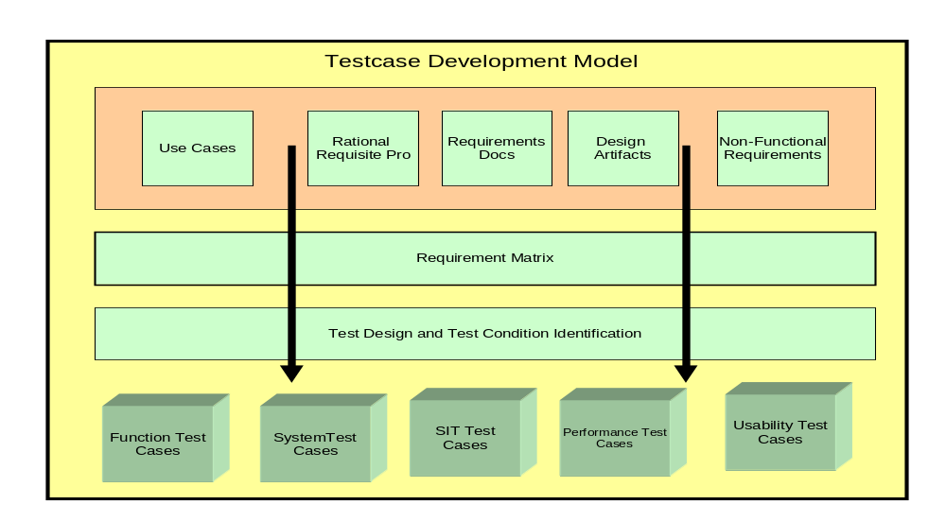
- Highlights of Test Case Development Model:
  - Concept - (4) key layers are cited in the illustration above: Requirement Sources Layer, Requirement Matrix/List Layer, Test Design/Test Condition Layer and the Test Case Layer
  - Requirements Source Layer – This layer represent the various sources of Business and System Requirements. There are reference documents available to the Test Team
  - Requirement Matrix Layer - The Requirement List/Matrix is the second row and is produced from RequisitePro which is the repository of requirements.
  - Test Design/Test Condition Layer – This is the layer where analysis is performed by the Tester. From this analysis, test objectives and test conditions can be identified that will ultimately be included into test cases.
  - Test Cases/Scripts Layer – Various types of Test Cases will be created to support CCA Testing
- See Use Case Survey in Appendix A
- See Non Functional Requirements in work product: ARC 119 Non-Functional Requirements
- Requirements Matrix in Rational RequisitePro is not available as of 01/24/2007

Test Data to Achieve Coverage

Solid and complete Test Data is essential to defect discovery. In support of the CCA Desktop Solution, Test Data will be provided by the CIGNA Team. As you will observe in the illustration below, test cases will be an input into the exercise to determine test data.
Regarding Test Data for CCA, early discussions have started with the CIGNA team and these discussions indicate that test data acquisition will be sufficiently complex given the location of test data in multiple repositories. The CIGNA team has cited a process entitled “Functional Testing Data Mockup Strategy” and this process identifies tools utilized for test data acquisition namely:
- Princeton Softech
- File aid for DB2/Spufi
- File aid for MVS
- Debugger Tools
  - Expediter
  - WASD – WebSphere
  - VB internal debugging from design mode
The CIGNA Data team also cited the major repositories namely CED, CDB, ePro and CPF. Additional collaboration with the CIGNA team must occur to develop a plan for test data access in support of Function, Sys Test, Sys Integration Testing and UAT Testing. The test data plan will be revised if necessary when the CIGNA Book of Record / Data Services strategy is complete.

Figure 16: Test Case to Requirements Mapping Model
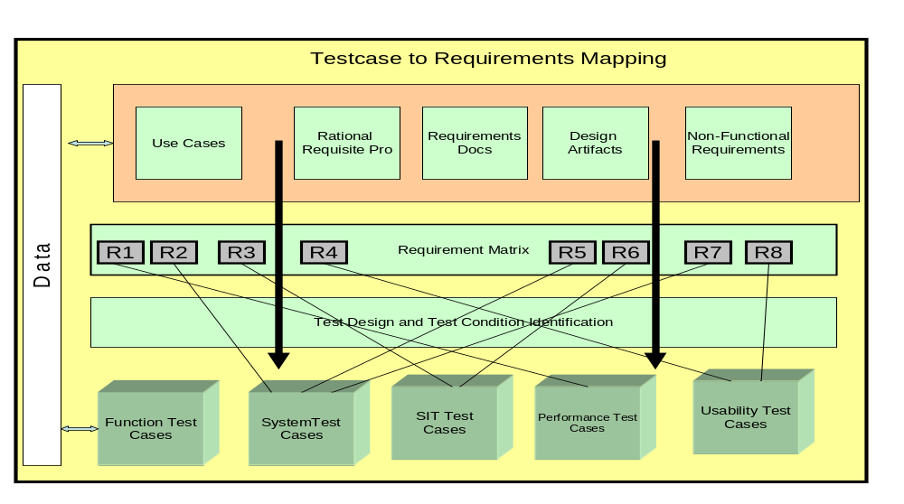
- Test Data – in the illustration above, you will see the Data Process noted on the far left. Test Data is necessary to support the Test case layer at the bottom row of the illustration. Test Data is determined by both the requirement layer on top and the Test case Layer on bottom.
- Once Test Data is loaded to support the various test cases, the test cases can be mapped backed to the requirement matrix layer and to a specific requirement (R1,R2, R2, Etc).

Requirements Traceability
Upon the completion of the Traceability Matrix, additional mapping can be done to ensure that test case exist for all requirements identified in the Traceability Matrix.
Figure 17: Requirements Mapping
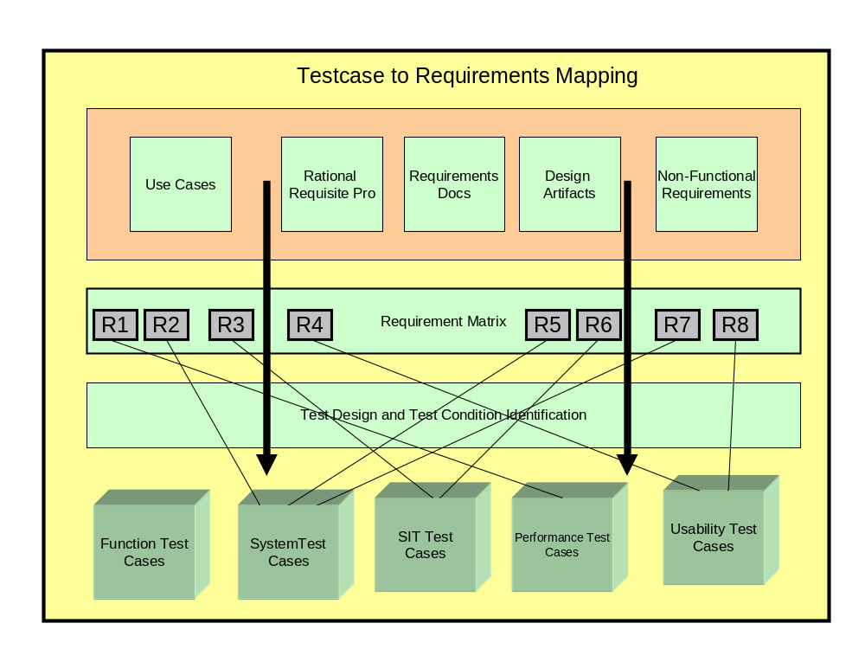
- All Functional and Non-Functional Requirements will be listed in Rational RequisitePro.
- All Functional and System Test Cases will be listed in Rational TestManager.
- All Requirements in RequisitePro will be linked to at least one Test Case in TestManager.

Processes and Procedures

Configuration Management and Build
Below is the required level of Configuration Management, listed by environment:
Environment | Sign Off
Development | No Sign off needed, Developers may deploy their code as they see fit
Function/System Test | All code must be checked in to ClearCase and built by Build Manager from ClearCase. Development Lead signs off that all Unit Test Cases have been performed and passed.
SIT/UAT Environment | All code must be checked in to ClearCase and built by build manager from ClearCase. Function Test Lead signs off that all Function Test has been performed and passed. Once all SIT Test Cases have passed UAT will begin in the same environment.
Pre-Prod/Performance Test | Once the build has passed SIT and has entered into UAT, the same build will be graduated to the Pre-Prod/Performance Test Environment to undergo Performance and Volume testing. The build will be moved to Pre-Prod only after the System Integration Test Lead signs off on the SIT Test Cases.

Test Status Reporting
Reports will be finalized and customized at the beginning of the Build Phase. The System Test phase will involve rigor and structure around test progress reporting. A summary test log will be kept, with results for testing documented on the individual test case documents and defects recorded in Rational ClearQuest tool.
All defects will be tracked in Rational ClearQuest and reports will be generated as needed from ClearQuest. The Testing Leads will go through a Defect list and status daily with the Development Leads, updating and prioritizing defects in that meeting as needed.
Figure 18: Defect Lifecycle
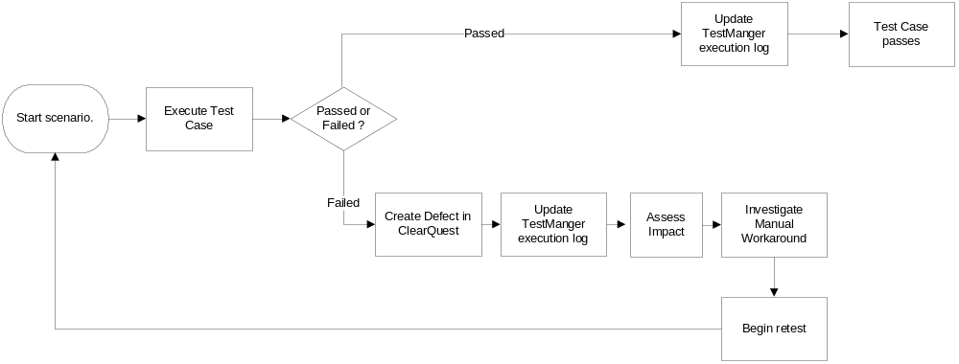

Defect Management Process

CCA Application Defects
The Defect Management Process involves multiple steps to ensure adequate focus on all anomalies identified during testing. Key steps are as follows:
- Defect Identification – This step is initialized when a tester discovers an anomaly. The anomaly must be in a state that it can be reproduced. An anomaly can be defined as an error, what appears to be an error, system state not identified in requirements documentation or other unexplained system state. The anomaly is then logged into the defect tracking tool for additional analysis and assignment.
- Defect Assignment – The defect tracking tool will direct the defect to an individual typically a development Lead. This lead will perform preliminary analysis and either sends the defect forward for repair or return the defect to the creator as not being a problem.
- Builds / Fix Packaging – Once the defect is repaired by the developer, it is marked as repaired in ClearCase and the Build Master will Build and Package the defect for installation into the test environment.
- Regression and Closure - The Test Manager will determine when to install a fix into the test environment. Once the defect is installed, it is verified as fixed by the creator or designate.

Infrastructure Defects
This testing strategy is focused on application testing. The testing of the infrastructure is separate and independent from application testing except when a hardware failure causes the suspension of testing. If a hardware failure occurs during one of the dynamic testing phases (Unit, Function, Sys Test, Sys Integration Testing or User Acceptance Testing), the defect will be logged to ClearQuest and assigned to the Infrastructure Project Manager. He will then open other problem tickets (Tivoli, etc) to drive the repair action.

Test Defect Reporting
When a defect is discovered, and through the life cycle of the defect, a great deal of information needs to be stored, so that review sessions will be effective and the development group will be able to place the defect in context. When a defect is discovered in the course of a test, the defect, whether it is a defect in the system or a defect in the code, will be logged in the defect tracking system. This information will be used by the System Test Lead to move forward with the resolution. The System Test Lead decides whether the defects discovered are valid, are enhancements, or are duplicates of existing defects, and the Severity classification. The System Test Lead will then assign the defect to a Development Lead or Assigner who will in turn assign a developer to the defect, and determine how it will proceed for resolution. The project will use Rational ClearQuest as the defect tracking system for daily management of defects.
Defect reports that are logged will follow through a complete cycle of testing events and will be tracked through different statuses. Defect statuses are:

Figure 19 Defect Status
Status | Definition | Owner
Submitted | Opened by a tester and waiting for evaluation by Dev Lead and resource assignment. | The Development Lead
Assigned | Resource identified and research is underway. | The Developer
Opened | Issue identified and re-creatable in development environment – working on fix. | The Developer
Resolved | Issue has been fixed and unit tested in development environment, is in build and waiting for Test Team to verify | The Tester
Verified | The defect has been retested by test team and verified that the fix is valid. | No Owner Closed out
Postponed | Issue still exists but has been accepted by the business – defect will remain open until defect has been fixed. | The Development Lead
Closed | Defect was not a valid defect, as agreed upon by the Development and Test Leads. | No Owner Closed out
Duplicate | The defect has been opened and is a duplicate, it will then be linked to the predecessor and marked as a duplicate | No Owner Closed out

Test Completion Report
The goal of this final report is to summarize the test activities for the CCA Testing project and to provide the test team with an opportunity to evaluate the test process as a whole. A final draft of the Test Completion Report will be ready after Rollout to Pre-Production. It will be delivered to available approximately 10 business days after go-live.

Test Requirements
Rational RequisitePro is the requirements management tool for the CCA Desktop project. RequisitePro provides the capability to maintain and document requirements while leveraging analytical capabilities such as requirements analysis, coverage and change impact.

Test Assumptions
This section identifies assumptions made when formulating this Testing Strategy:
- Adequate and sufficient testing resources are available when needed.
- Baselined and Final Requirements are available before Test Planning begins. Changes to requirements will occur under Change Management.
- SME’s are identified in support of the testing efforts before Test Planning begins.
- Unit Testing and peer reviews are conducted, results documented and any Unit Test defects resolved prior to Function Test.
- The SIT test environment is ready and functioning before (+2 weeks) SIT is scheduled to begin
- Developers will not make code changes to objects within the SIT Libraries. Introduction of fixes must occur through Configuration Management
- Code is locked-down and turned over to testing before System Test.
- Code Stubs are removed bassed on the agreed upon System Test schedule.

Test Constraints
This section identifies obstacles beyond the control of the testing team that may limit the testing process.
- Completeness and Accuracy of Technical Documentation for Test Design and Test Case preparation.
- Completeness and Accuracy of Test Environment
- Unavailability or late delivery of required hardware, software, data or tools.

Risks
The following have been identified to date. Additional risks may surface as testing progress.
- Test Preparation risks stemming from unfinished levels of detail regarding Business Rules, UI Designs, Roles Based Security Requirements and Use Cases.
- Architectural complexity of CCA Desktop
- Lack of Rational Tools infrastructure in place during Requirements Gathering and Use Case Sessions. All requirements are currently not in RequisitePro.
- Data Integration
- The availability of a CIGNA Test Environment for testing is planned at the Release Testing Milestone. This is much later than the usual readiness point which is the UAT milestone for typical CIGNA Projects.

Impact of the Iterative Approach
It will be important to do regression testing of functionality delivered in an iterative build when the code is going to be re-delivered for a subsequent iterative build. For System Test, regression testing will occur to assure a fix for one application features does not break the functionality delivered in another build. Regression testing will use existing test cases that have already passed on prior runs. The suite of regression test scripts will be identified by selecting the most common and most critical functionality. Early regression testing will be done manually, but as the code base becomes stable the regression test suite will be automated.
Managing defect resolution and the code itself will be complicated by the iterative approach. When a defect is encountered in a build it will have to be fixed in the iteration in which it was found. Once fixed and retested, the fix will have to be merged into the instance of code being prepared for the next iterative release. All Critical and High (see section 8.1 of this document) defects will have to be fixed in the iteration which they were found. Due to time constraints, if a defect (Medium or Low) defect is identified, but can not be fixed/retested, the fix must be designed into the subsequent build and also must be added back into the System Test plan to be specifically tested by the Test Team. Unresolved defects must adhere to the System Test Exit Criteria before moving to SIT Test. Any defects that have not been resolved will be regression tested in the Functional/System Test Environment
Additionally, because Functional and System Test occurs in the Functional/System Test environment, the System Test scripts that are required to ensure 100% requirements coverage will eventually be re-executed (or regression tested) in the SIT environment to ensure that there are no environment specific issues with the application.

External Dependencies
CCA Desktop Testing has surfaced the following Table of Dependencies:
Figure 20: Test Dependencies
Category | Description | Ownership
Test Environments | Test Environments, including hardware and software maintenance, are provided by Shared Services Team | Shared Services
Test Data | Test Data is created and provided to CCA Testing by CIGNA.  - Ownership of test data not yet defined  - Timelines for data delivery not yet established | CIGNA - TBD
Test Tool Installation | Server installation of Testing Tools resides outside of the test team. Currently, the Rational Tool Set namely ClearQuest, ClearCase, BuildForge, RequisitePro and TestManager are needed in support of CCA testing. | Shared Services
Configuration Management and Driver Builds | Driver Builds are provided by a separate team from Testing. | Shared Services
Subject Matter Expertise for Test Scenario input and Test case Reviews | CCA SME/Business Analysts are required to provide input into SIT Scenarios. This expertise is also required for ST/SIT Test case Review. | CIGNA – TBD
UAT Testing. Subject Matter Expertise for Test Scenario input and UAT Test case Reviews | CCA SME/Business Analysts are required to provide input into UAT Scenarios. This expertise is required for UAT Test case Review. | CIGNA - TBD

Key Input Documents
This section defines the documentation baseline of factual content that feeds the Master Test Plan Document.
The table below identifies the documentation that is available within the project and the artifacts, documents or models that are referenced for this strategy.
The document archive resides in RPM.
Figure 21: Key Input Documents – Deliverables
Document (and version) | Author or Resource | Target | Archive
Solution Outline – Requirements Report |  |  | RPM
Business Rules Catalog |  |  | RPM
System Context Work Product |  |  | RPM
Incremental Requirement List |  |  | RPM
Use Case Survey Work Product |  |  | RPM
CCA Project Charter |  |  | RPM
Usability Requirements Work Product |  |  | RPM
APP 141 Test Strategy | Willie Mims |  | RPM

Resources

Roles and Resources
Figure 21: Roles and Resources
Role Name | Responsibility
CIGNA Test Liaison  CRM Capabilities QA and Testing  - Mr. Gerald MacDonald | - CIGNA Liaison contact for all program wide testing activities in support of CCA Application Testing  - Issue Management focal point  - Key Interface to the CIGNA Testing Community
CIGNA Business Unit Testing Contact | - UAT Test Preparation and Execution Owner. This role is a place holder role for now until final discussion occurs with Senior Management.
CIGNA Test Data Contact | - Contact into the CIGNA Team for Test Data acquisition  - Has technical and business bandwidth to address CIGNA data requirements created by the IBM Test Team  - Familiar with support of vendor based development and data issues to support data access by remote servers.
IBM Test Manager  CRM Capabilities QA and Testing  - Mr. Willie Mims | - Test Team Leadership and Project Management  - Provides central coordination for all testing activities in support of the CCA Application Testing.  - CRM Capabilities Test Strategy Owner  - Testing Issue, Risk and Dependency Management Focal Point  - Test Reporting, Project Planning and Test Execution Leader  - Technical leadership of CCA Test Personnel
CCA Lead Testers  - Tiffany Lowery  - Kurt Solarte | - Primary contact point for testing status and strategy for CCA  - Generates and administers the Test Plans and Strategies specifically Unit, Integration and System Test Plans  - Provide Test Methodology expertise consistent with IBM Global Services Method  - Perform selection and tailoring of application testing tools platforms  - Technical leadership of CCA Test Personnel
Testers / Analysts / Engineers  - TBD | - Facilitate the CCA testing processes  - Create Testing Artifacts including Test Designs, Specifications and Test Results  - Applies methodologies to achieve Quality and Schedule Objectives  - Resolve issues and manage risks  - Consolidate the test status on specific functionality and make technical recommendations on test methods and approaches  - Leverage Test Automation Tools to improve efficiency and productivity within the testing process.

Test Environments
This section lists the environments for each test stage.
Figure 22: Environments
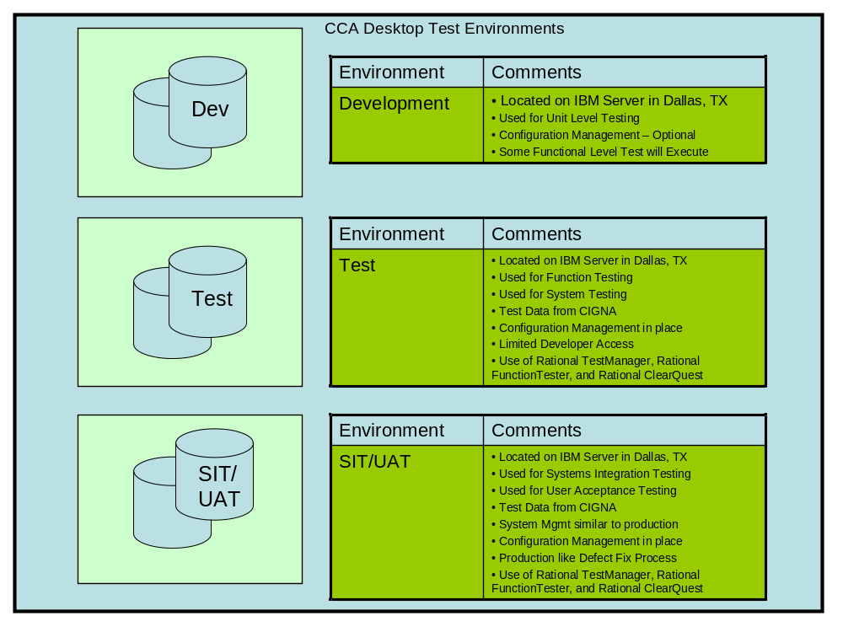
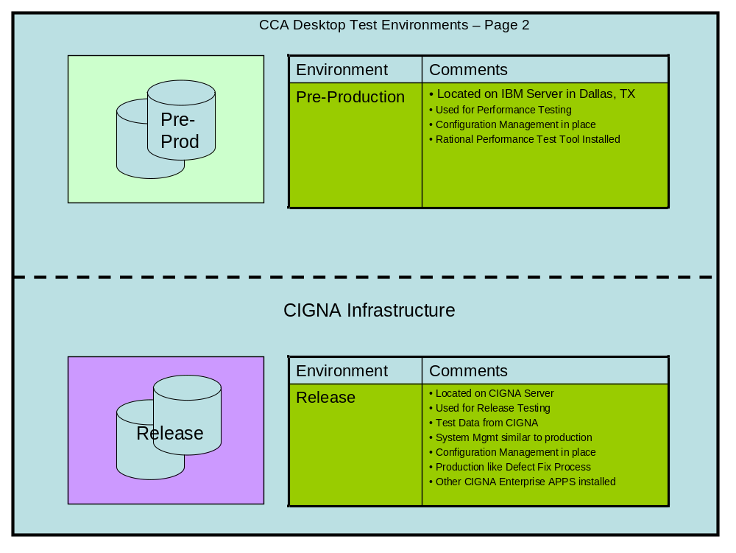
The above chart identifies test environments to be built and managed by the IBM Data Center.
It is noted that CIGNA will need to ready environments for Release Testing. The information needed for environment planning is typically provided by the deployment team.
A risk will be posted to the Testing Risk log to highlight the availability of a CIGNA Test Environment is planned at Release Test Milestone with is later than the normal System Integration Milestone.

Tools
This section identifies the tools needed to perform testing on the CCA Application.
Figure 23: Testing Tools
Tool Type | Tool/Version | Vendor/In-house
Test Management | Rational TestManager 7.0 | IBM Rational
Defect Tracking | Rational ClearQuest 7.0 | IBM Rational
Requirements Management | Rational RequisitePro 7.0 | IBM Rational
Code Repository | Rational ClearCase 7.0 | IBM Rational
Automated Tool | Rational FunctionalTester 7.0 | IBM Rational
Unit Test Tool | JUnit OpenSource Project 4.0 | SourceForge
Performance Testing | Rational PerformanceTester | IBM Rational
Project Management | MS Project | Microsoft
DBMS tools
Configuration Management | Rational ClearQuest | IBM Rational

Per SOW guidance, the IBM Rational Tools are used for CCA Development. For audit reasons, it is expected that the IBM tools set will contain the artifacts to satisfy audit requirements. In the case of defects, a bridge tool to the Rational Tool will be pursued. This is a tool created by Mercury and installs an agent that executes on both Rational ClearQuest and Mercury TestDirector.

Defect Management
The management of defects and repair actions are critical to maintaining the test execution schedule.
The following guidelines address defects discovered during CCA Desktop Testing.
- Developers or Testers can open defects in ClearQuest. The severity is assigned at the time of opening consistent with the Defect Severity Table.
- Repair times should conform to the turn-around schedule
- Developers flag the defects as resolved and ready for build
For Data Defects, CIGNA developers flag as repaired and ready for test. CIGNA Team will also flag data available and ready for test. This assumes that CIGNA will have access to IBM ClearQuest else an alternative must be provided
- Build Team or Configuration Management reps will perform the Build
- Defect authors will have responsibility for fix verification and defect closure
Defects that are logged will follow through a complete cycle of testing events and will be tracked through different statuses. Defect statuses are:
Figure 24: Defect Severity Codes
 | IBM Severity/Priority | Fixed Required | Description
 | 1=Critical | Immediate | Testing is totally blocked and there is no work around  A bypass (patch) is required within 12 hours  The actual fix is required within (2) days  This is the most severe problem  Example: Abends
 | 2=Major | 1 day | A major portion of test is partially blocked. Test can continue but with severe restrictions. A bypass will be accepted to temporarily get around the problem until fix is available  Example: Data Source Failure
 | 3=Average | 2 days | Testing is not stopped. Test can continue but with minor restrictions. A bypass is not normally required  Example: Sorted Data not correct.
 | 4=Minor | 4 days | Testing is not affected. The  Problem is insignificant and can usually be easily bypassed  Example: Format/Alignment errors

Timeline

Test Milestones
This section lists test milestones for CCA Desktop Testing project. They are listed in chronological order.
- Test Team engaged – This event initializes the test planning process. Planning, Prep and Execution step follows.
- Test Plan/Test Cases completed – This event signals the completion of Test case Design and Prep.
- Test Environment is setup and functional – This milestone signals the readiness of the Test Environment.
- Software Code Turnover (System Test begins) – Development Testing (Unit and Function) is complete.
- System Test Complete – The solution has matured and signals readiness for SIT/UAT Testing.
- Test Analysis complete (Go/No-go recommendation) – Testing Phases are now complete and a recommendation can be made regarding move-to-production.
- Test Completion Report – Signals the end of the project.
Refer to the CCA Project Plan on RPM repository for additional information on dates.

Conceptual Schedule
The table below is intended as a high-level schedule overview for the CCA Desktop Testing effort. The CCA Desktop Project Schedule is being assessed. The dates below will be adjusted based on the project assessment. The Final CCA Desktop Project Schedules will be published in the CCA Desktop Project Plan.
Figure 25: Conceptual Schedule
Milestone | Target Completion Date
Completion of Macro Design | 01/26/07
Completion of Release 1 Iteration 1 (Build) | 06/30/07
Completion of Release 1 User Acceptance Test | 07/18/08
Completion of Release 2 Iteration 1 | 11/28/08
Completion of Release 2 User Acceptance Test | 07/17/09

* Finalization of dates still pending.

Deliverables

Test Deliverables
This section contains a table that identifies all artifacts (work products) delivered by the Test team.

Figure 26: Matrix of Test Deliverables
Development Stage | Document  (Artifact) | Document Name | Author
Test Planning | Test Strategy | CCA Desktop Test Strategy | Willie Mims
Test Planning | Test Plan [s] and Specifications |  | IBM Team
Test Planning | Acceptance Test Plan |  | IBM Team
Test Execution | Test Cases/Results |  | IBM Team
Test Execution | Test Progress Reports |  | IBM Team
Test Analysis | Updated Req. Traceability Matrix |  | IBM Team
Test Close Out | Test Completion Report |  | IBM Team
Test Close Out | Defects |  | IBM Team

Approval of the above list will be guided by the Program SOW and Contract.

Book of Record
IBM is using the Rational Tool Set. For clarity, Defects and Test Cases will be stored in support of any audit requirements. At project completion, IBM can provide PDF formats for all artifacts stored in the Rational Tools. PDF formats are open architecture and can be read by non Rational Tools.

Metrics
The following test metrics will be developed and tracked throughout the CCA project.
Figure 27: Metrics
Format | Description |  | Method of Report | Audience | Measure of  Coverage
% |  | Requirements covered by Test Cases.  Target = 100% {Reported by Project} | Test Completion Report | Stakeholder | Test team Quality
# |  | Test Cases that cannot be executed due to environmental limitations/issues. | Test Completion Report | Stakeholder | Environment Quality
Progress Metrics
# And % | Test Cases Executed vs. Test Cases Planned Target = based on length of test window |  | Weekly Progress Report | PM  Stakeholder | Test team Efficiency
# | Defects found vs. Test Cases Executed {Reported by Defect Severity Category} |  | Weekly Progress Report | PM  Stakeholder | Development Quality

Appendix

Appendix A: Use Case Survey
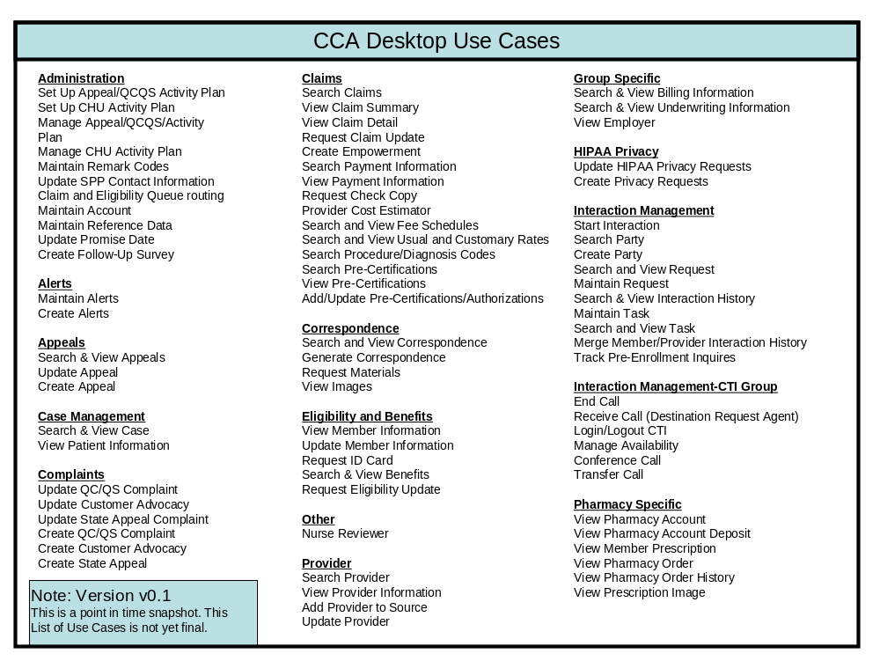

Appendix B: Test Entrance Criteria
The following entrance criteria must be completed before System Test Entry. Several items on this list should be completed much earlier in the testing lifecycle that just prior to test execution and are included here to provide traceability.
ENGAGEMENT/RELEASE: ______________________________________
Figure 28: Test Entrance Criteria
TEST EXECUTION ENTRANCE CRITERIA | YES | NO | N/A | NOTES
Configuration Management (CM)/Release Management (RM) AREA RESPONSIBILITIES
A configuration management process has been established and documented to handle requested changes to Project documentation
Location:
The code migration process has been documented and arrangements made to accommodate testing
Location:
A release schedule has been established and documented. This schedule must include periodic planned builds for defect fixes while in test
Location:
Turnover Package: All code changes are identified in documentation and made available to the RM and Test team. This includes DB changes, install scripts/instructions, structure changes, etc.
Location:
Code to be tested is locked-down and ready to be moved into the test area.
Validated By: | Date:
Testing environment baseline updated with release baseline. (i.e. the code and program versions in the test environment = that of production)
Validated By: | Date:
PROJECT/BUSINESS AREA RESPONSIBILITIES
Test team members have been involved in Project meetings since the definition phase
Validated By: | Date:
At least one Test team member is on all applicable project communications lists
Validated By: | Date:
Requirements document has been baselined, is under configuration control, and has been made available to the Test team for review
Location:
All Design documentation has been baselined, is under configuration control, and has been made available to the Test team for review
Location:
A business and/or systems SME has been identified and assigned to support the testing effort and is listed in the Test Plan
Validated By: | Date:
DEVELOPMENT AREA RESPONSIBILITIES
Independent code reviews/Peer reviews completed and documented
Location:
Unit testing results documented and reviewed by testing team
Location:
Unit test defects fixed, validated or otherwise properly dispositioned and documented
Validated By: | Date:
A development SME has been identified and assigned to support the testing effort (and is listed in the Test Plan)
Location: | Date:
All needed support files (such as account lists, flat file inputs, ini files, etc.) have been identified and provided where applicable (should be part of Turnover Package)
Location:
DEFECT MANAGEMENT AREA RESPONSIBILITIES
The Defect Process/Workflow has been documented and implemented
Location:
All Project personnel have been trained in and have appropriate access to the tracking tool
Validated By: | Date:
A Defect Manager has been identified, allocated, and trained
Defect Manager:
TEST AREA RESPONSIBILITIES
Test Plan(s) completed and approved.
Location:
Test Cases/Scripts completed and approved
Location:
Test cases have been traced to business and/or systems requirements through a Requirements Traceability Matrix (RTM)
Location:
SUPPORT AREA RESPONSIBILITIES
A unique test environment has been reserved and under CM control
Validated By: | Date:
The Test Environment has been verified as accessible and functioning. This includes connectivity to all applicable systems
Validated By: | Date:
All applicable Test Tools have been installed, verified as functional, and user guide/documentation up-to-date
Location:
Proper User Ids and permissions needed for testing have been obtained and verified
Validated By: | Date:
Test data has been received and pre-tested for validity
Validated By: | Date:
- Deployment and installation instructions have been successfully executed and validated
Validated By: | Date:
Points of contact have been assigned for their various component responsibilities. (and are listed in the Test Plan)
Verified By: | Date:
All applicable Service Agreements are in place and updated if needed, including clear ownership of Incident Resolution
Location:
GENERAL MANAGEMENT RESPONSIBILITIES
Any training required by testing personnel has been completed
Validated By: | Date:
Any waivers or exceptions to the above have been documented and approved
Location:

RECOMMENDED ACTION

TESTING MAY PROCEED:

NO Sign-off by: __________________________________
Test Manager

YES Title: Date:

YES, WITH THE FOLLOWING RISKS NOTED:
CRITERIA # | RISK or IMPACT | MITIGATION

Appendix C: Test Exit Criteria
The following exit criteria must be met to complete the Test Execution and Test Analysis phases of testing.

ENGAGEMENT/RELEASE: ___________________________________
Figure 29: Test Exit Criteria
TEST EXIT CRITERIA | YES | NO  Planned Date | N/A
1. Any updates to test documentation have been completed and are under CM control.
2. Test Cases have been executed according to the test plan and any deviations documented and approved.
3. All required test types have been completed (e.g., regression, end-to-end, performance etc.)
4. All defects have received a final disposition (i.e. open, closed, postponed, invalid, duplicate)
5. Sign-off has been obtained from designated stakeholders indicating test completion.
6. Other Test Completion and Validation conditions, as specified in the Test Plan, have been met.

RECOMMENDED ACTION

TESTING HAS SUCCESSFULLY COMPLETED:

NO Sign-off by: ____________________________
Test Manager

YES Title: Date:

YES, WITH THE FOLLOWING RISKS NOTED:
CRITERIA # | RISK or IMPACT | MITIGATION

Appendix D: Test Plan Glossary
This testing glossary is intended to provide a set of common terms and definitions as used in IBM’s Testing Methodology. Many of these terms are in common use and therefore may have a slightly different meaning elsewhere.
Figure 30: Test Plan Glossary
Term | Definition
Acceptance Testing | (1) Formal testing conducted to determine whether or not a system satisfies its acceptance criteria and to enable the client to determine whether or not to accept the system. (2) Formal testing conducted to enable a user, client, or other authorized entity to determine whether to accept a system or component.
Backup and Recovery Testing | A structural type of test that verifies the capability of the application to be restarted after a failure.
Build | (1) An operational version of a system or component that incorporates a specified subset of the capabilities that the final product will provide. Builds are defined whenever the complete system cannot be developed and delivered in a single increment. (2) A collection of programs within a system those are functionally independent. A build can be tested as a unit and can be installed independent of the rest of the system.
Change  Management | A process methodology to identify the configuration of a release and to manage all changes through change control, data recording, and updating of baselines.
Conversion testing | A functional type of test that verifies the compatibility of converted programs, data and procedures with the “old” ones that are being converted or replaced.
Coverage Matrix | Documentation procedure to indicate the testing coverage of test cases compared to possible elements of a program environment (i.e., inputs, outputs, parameters, paths, cause-effects, equivalence partitioning, etc.)
Data flow Testing | Testing in which test cases are designed based on variable usage within the code.
Defect Management | A set of processes to manage the tracking and fixing of defects found during testing and to perform causal analysis.
Detailed Test Plan | The detailed plan for a specific level of dynamic testing. It defines what is to be tested and how it is to be tested. The plan typically identifies the items to be tested, the test objectives, the testing to be performed, test schedules, personnel requirements, reporting requirements, evaluation criteria, and any risks requiring contingency planning. It also includes the testing tools and techniques, test environment set up, entry and exit criteria, and administrative procedures and controls.
Entry Criteria | Checklists of activities or work items that must be complete or exist, respectively, before the start of a given task within an activity or sub-activity.
Error Handling Testing | A functional type of test that verifies the system function for detecting and responding to exception conditions. Completeness of error handling determines the usability of a system and ensures that incorrect transactions are properly handled.
Exit Criteria | (1) Actions that must happen before an activity is considered complete. (2) A checklist of activities or work items that must be complete or exist, respectively, prior to the end of a given process stage, activity, or sub-activity.
Operability Testing | A level of dynamic testing in which the operations of the system are validated in the real or closely simulated production environment. This includes verification of production JCL, installation procedures and operations procedures. Operability Testing considers such factors as performance, resource consumption, adherence to standards, etc. Operability Testing is normally performed by Operations to assess the readiness of the system for implementation in the production environment.
Systems Integration Testing | A dynamic level of testing which ensures that the systems integration activities appropriately address the integration of application subsystems, integration of applications with the infrastructure, and impact of change on the current live environment.
System Testing | A dynamic level of testing in which all the components that comprise a system are tested to verify that the system functions together as a whole.
Test Case | - A set of test inputs, execution conditions, and expected results developed for a particular objective, such as to exercise a particular program path or to verify compliance with a specific requirement.  - The detailed objectives, data, procedures and expected results to conduct a test or part of a test.
Test Focus Areas | Those attributes of an application that must be tested in order to assure that the business and structural requirements are satisfied.
Test Matrices | A collection of tables and matrices used to relate functions to be tested with the test cases that do so. Worksheets used to assist in the design and verification of test cases.
Test Specification | A set of documents that define and describe the actual test architecture, elements, approach, data and expected results. Test Specification uses the various functional and non-functional requirement documents along with the quality and test plans. It provides the complete set of test cases and all supporting detail to achieve the objectives documented in the detailed test plan.
Validation | - The act of demonstrating that a work item is in compliance with the original requirement. For example, the code of a module would be validated against the input requirements it is intended to implement. Validation answers the question "Is the right system being built?”  - Confirmation by examination and provision of objective evidence that the particular requirements for a specific intended use have been fulfilled. See "Verification".

Appendix E: Screen Cap of RAD Test Harness
This is a screen capture from inside Rational Application Developer, showing how the tool allows the use of the WSDL to generate a client that in turn can be deployed to the Development or Functional Test Environment to allow the Test teams to Functionally Test the Web Service
Figure 31: Rational Test Harness Creation
